In this Document, E-ERD will be converted into a Relational Schema by 9 step algorithm. Step by step mapping is followed:

# Step 1: Mapping of Regular Entity Types

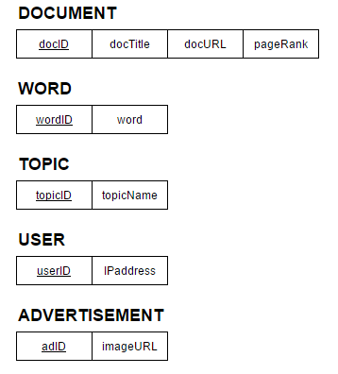

# Step 2: Mapping of Weak Entity Types

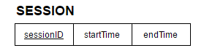

# Step 3: Mapping of Binary 1:1 Relationship Types

No 1:1 Relations.

# Step 4: Mapping of Binary 1:*N* Relationship Types

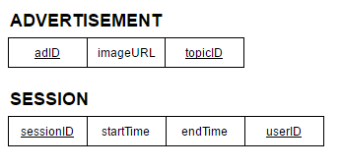

# Step 5: Mapping of Binary *M*:*N* Relationship Types

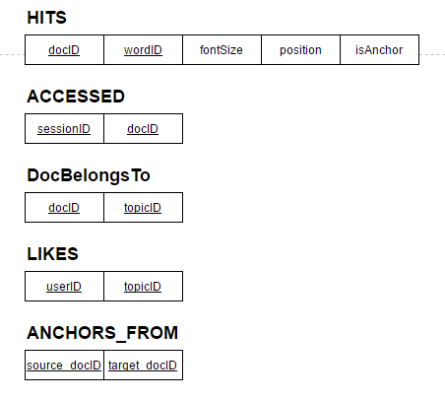

# Step 6: Mapping of Multivalued Attributes

No MultiValued Attributes.

# Step 7: Mapping of *N*-ary Relationship Types

No N-ary Relationship type.

# Step 8: Options for Mapping Specialization or Generalization

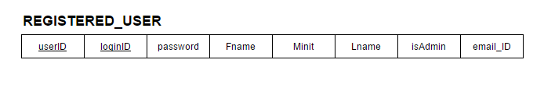

# Step 9: Mapping of Union Types

